Chapter 11, Solution 90

Original load :
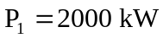, 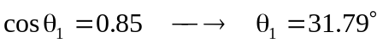
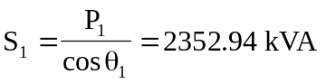
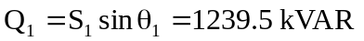

Additional load :
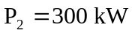, 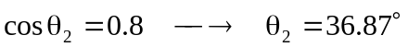
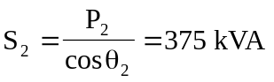
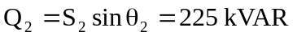

Total load :

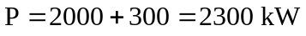

The minimum operating pf for a 2300 kW load and not exceeding the kVA rating of the generator is
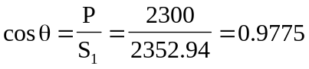
or 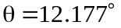

The maximum load kVAR for this condition is


The capacitor must supply the difference between the total load kVAR ( i.e. Q ) and the permissible generator kVAR ( i.e. 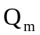). Thus,

